Software Design Document (SDD)
Module: GPIO Driver

Version | 1.0
Authors | David Mijares, Ximena Cedillo, Xavier Clemente
Files | GPIO.h / GPIO.c
Target MCU | STM32F411RE (Cortex-M4)
Course | Microcontrollers and Embedded Systems — CETYS Universidad

1. Introduction

1.1. Purpose
This document describes the software design and architecture of the GPIO driver module developed for the STM32F411RE microcontroller, as part of the Microcontrollers and Embedded Systems course at CETYS Universidad. The design is based on the code in GPIO.h and GPIO.c and provides details on data structures, enumerations, register-level algorithms, and control flow to guide implementation and testing.
This SDD serves as a reference for maintenance, testing, and future improvements of the GPIO Control System firmware.

1.2. Scope
The GPIO driver is a low-level software component for embedded systems. It abstracts hardware registers and provides a clean C API for higher-level modules to configure and control digital I/O pins on the STM32F4xx without accessing hardware registers directly. The system performs the following specific operations:
- Initializes the gpio[] pointer array mapping all supported GPIO ports.
- Enables and manages peripheral clocks via the RCC AHB1ENR register.
- Configures individual pin modes (input, output, alternate function) via the MODER register.
- Atomically sets or clears output pins using the BSRR register.
- Toggles pin states by XOR on the ODR register.
- Reads the current digital state of any pin via the IDR register.
- Assigns alternate functions (AF0-AF15) to pins via the AFR registers.
- Does not depend on HAL libraries — all hardware interaction uses direct MCU register access.

1.3. Definitions and Acronyms
Term | Definition
GPIO | General Purpose Input/Output
Port | A collection of up to 16 GPIO pins grouped under one peripheral (e.g., GPIOA, GPIOC)
Pin | A single digital input/output line within a port (numbered 0–15)
RCC | Reset and Clock Control — enables GPIO port clocks via AHB1ENR register
MODER | GPIO Mode Register — input(00), output(01), alt function(10), analog(11)
BSRR | Bit Set/Reset Register — atomic set bits[15:0] and clear bits[31:16]
ODR | Output Data Register — current driven output state of each pin
IDR | Input Data Register — current logic level on each pin
AFR | Alternate Function Register — AFR[0] pins 0-7, AFR[1] pins 8-15
HAL | Hardware Abstraction Layer — NOT used; driver uses direct register access
CMSIS | Cortex Microcontroller Software Interface Standard — provides GPIO_TypeDef / RCC_TypeDef
MCU | Microcontroller Unit — refers to the STM32F411RE in this document
API | Application Programming Interface — the public function set exposed by the driver module
port_t | Enumeration type for selecting GPIO ports: A, B, C, D, E, H, GPIOs_SIZE
FR-x | Functional Requirement x as defined in this document

1.4. Requirements
All functional requirements implemented in GPIO.h / GPIO.c are listed below.
Req. ID | Type | Description
FR-1 | Functional | gpio_init() shall assign all gpio[] array positions to the corresponding STM32 GPIO peripherals.
FR-2 | Functional | gpio_initPort() shall enable the AHB1 peripheral clock for the specified port via RCC->AHB1ENR.
FR-3 | Functional | gpio_setPinMode() shall configure the 2-bit MODER field for the specified pin using read-modify-write.
FR-4 | Functional | gpio_setPin() shall atomically drive the specified pin HIGH via BSRR bits[15:0].
FR-5 | Functional | gpio_clearPin() shall atomically drive the specified pin LOW via BSRR bits[31:16].
FR-6 | Functional | gpio_togglePin() shall invert the current pin state by XOR on the ODR register.
FR-7 | Functional | gpio_readPin() shall sample the IDR bit for the specified pin and return its digital state (0 or 1).
FR-8 | Functional | gpio_setAlternateFunction() shall write the 4-bit AF number into AFR[0] or AFR[1] and set MODER to alternate function mode.

2. System Architecture

2.1. High-Level Design
The GPIO driver follows a layered firmware architecture separating application logic from hardware access:
- Application Layer: Contains application code that calls driver functions to control GPIO pins. Never accesses hardware registers directly.
- GPIO Driver Layer: Contains GPIO.c / GPIO.h. The only layer that accesses STM32 GPIO registers (MODER, BSRR, ODR, IDR, AFR) and RCC clock registers. Provides a validated C API to all upper layers.
- Hardware Layer: STM32F411RE GPIO peripheral registers and RCC, accessed through CMSIS GPIO_TypeDef and RCC_TypeDef structs from stm32f4xx.h. Not directly visible to any layer above the GPIO driver.

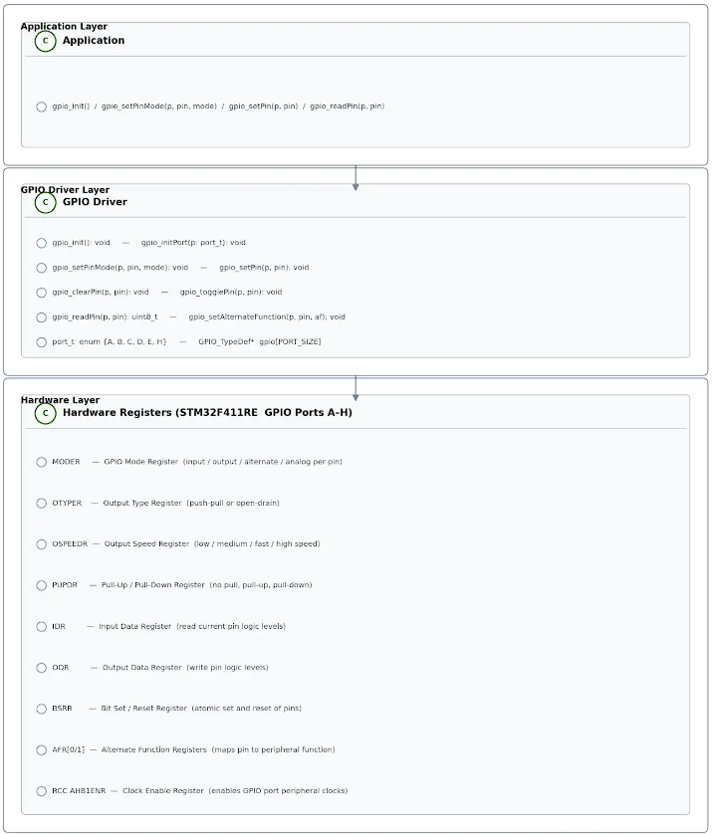
Fig. 1 — Class Diagram: GPIO Driver Module

Fig. 1 shows the GPIO driver module's public interface. The gpio[] array of GPIO_TypeDef* pointers is the core internal structure. All public functions index into this array using the port_t enum value passed by the caller.

2.2. Module Interfaces
- Public API: Functions declared in GPIO.h with the gpio_ prefix. All functions return void except gpio_readPin() which returns uint8_t.
- Global State: extern GPIO_TypeDef* gpio[GPIOs_SIZE] — array of hardware pointers populated by gpio_init().
- Dependencies: stm32f4xx.h (CMSIS GPIO_TypeDef, RCC_TypeDef), stdint.h. No HAL or LL library required.

3. Detailed Design

3.1. Module Description

A. GPIO Driver Module (GPIO.c / GPIO.h)
Responsible for generic GPIO configuration and control. Provides the complete low-level register abstraction for all GPIO operations on the STM32F411RE.
Responsibilities: populate the gpio[] pointer array; enable GPIO peripheral clocks via RCC AHB1ENR; configure pin modes (input, output, alternate function, analog) via MODER; control output state atomically via BSRR; read input state from IDR; configure alternate function registers (AFR); and validate all arguments before hardware access.

3.2. Module Behavior — Overview Diagrams
The following sequence and state diagrams illustrate the overall system behavior before per-function details.

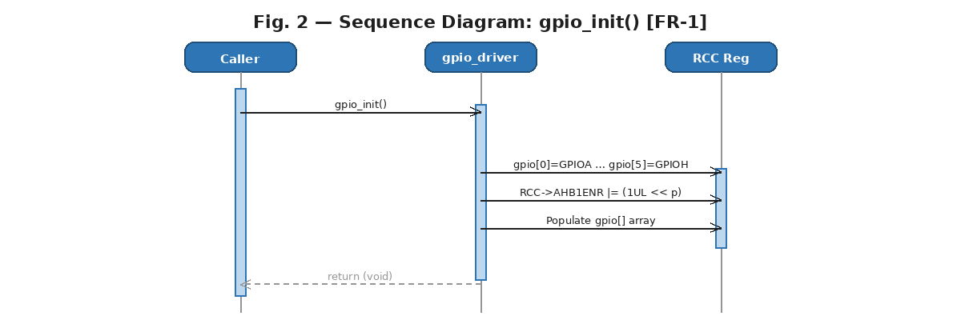
Fig. 2 — Sequence Diagram: gpio_init() [FR-1]

Fig. 2 shows the internal call chain of gpio_init(). The function assigns all six entries of the gpio[] array to their STM32 hardware base addresses, then returns void.

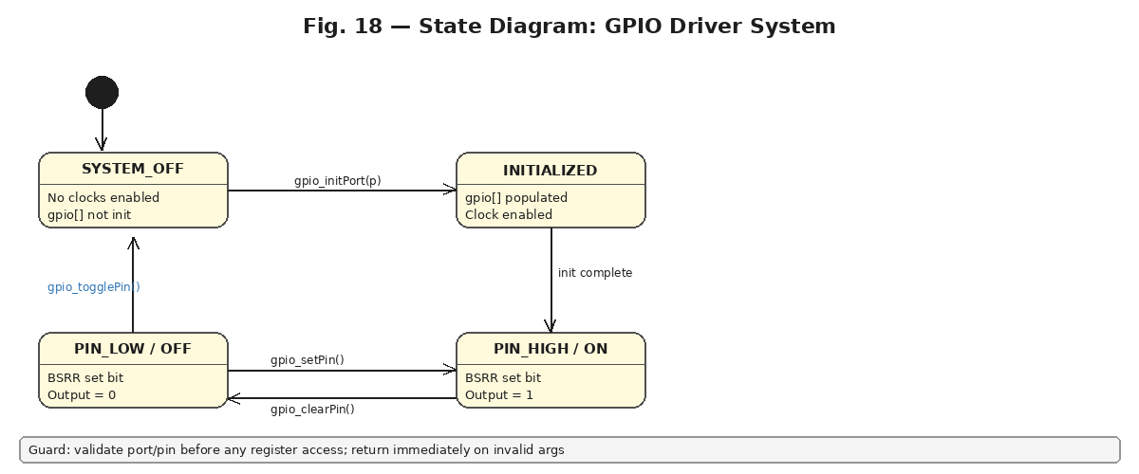
Fig. 3 — State Diagram: GPIO Driver System

Fig. 3 illustrates the runtime states of the GPIO system. Before initialization no hardware is accessible. After gpio_initPort() enables the clock, pins can be driven HIGH, LOW, or toggled. The guard on all transitions is argument validation.

3.3. Per-Function Sequence and Activity Diagrams

gpio_init() — FR-1: System Initialization
The sequence diagram shows that gpio_init() takes no parameters and returns void. It populates the gpio[] array with CMSIS GPIO peripheral pointers for ports A through H.

Fig. 4 — Sequence Diagram: gpio_init() [FR-1]

The activity diagram confirms a purely linear flow with no decision nodes. Since the function has no parameters there is nothing to validate, and it always succeeds.
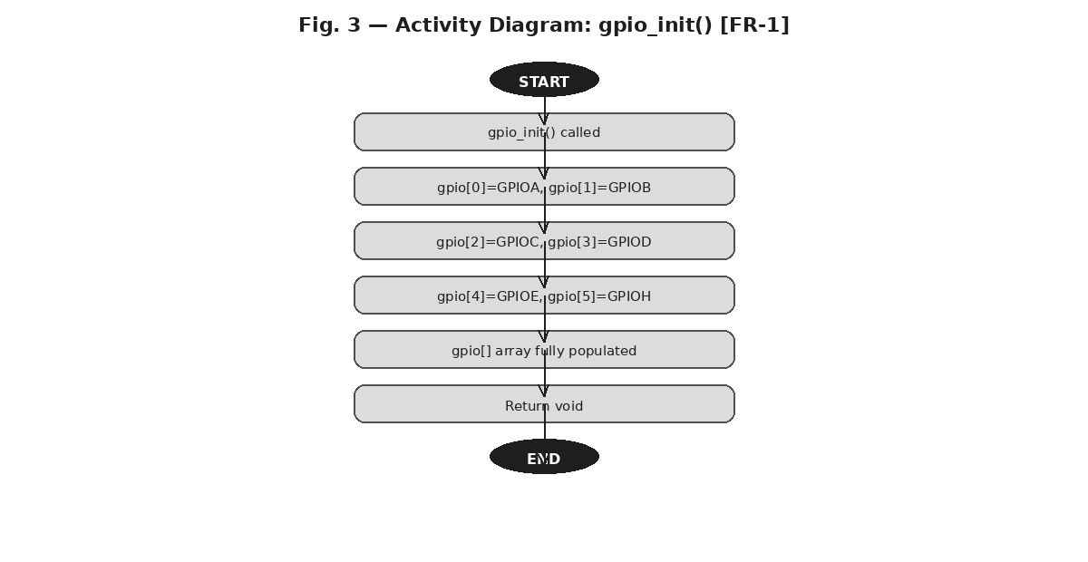
Fig. 5 — Activity Diagram: gpio_init() [FR-1]

gpio_initPort() — FR-2: Port Initialization
The sequence diagram shows the two execution paths: early return for out-of-range port values, and the normal path that enables the peripheral clock via RCC->AHB1ENR. Port H (enum value 5) is remapped to AHB1ENR bit 7.
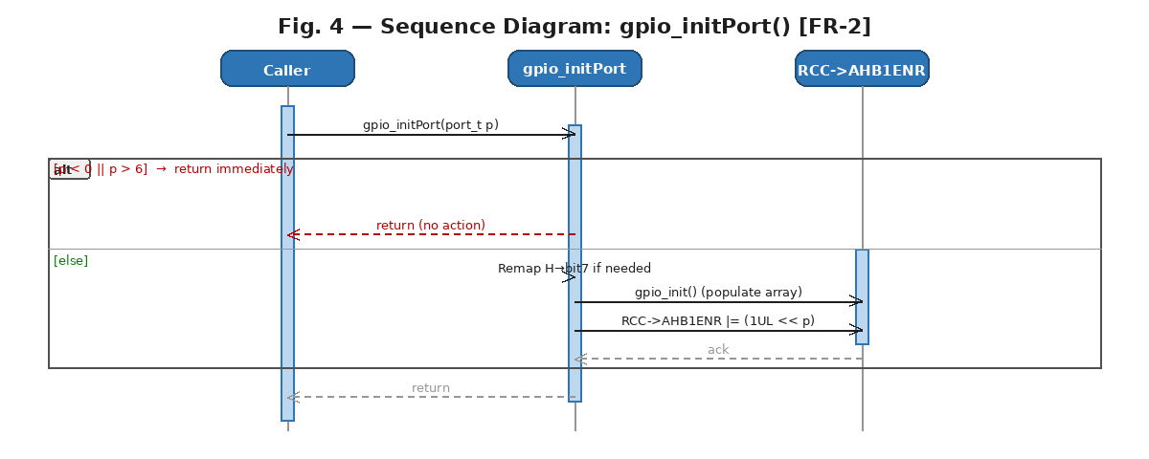
Fig. 6 — Sequence Diagram: gpio_initPort() [FR-2]

The activity diagram shows the validation decision node at the top, the H-port remap, the gpio_init() call to populate the array, and the clock enable write.
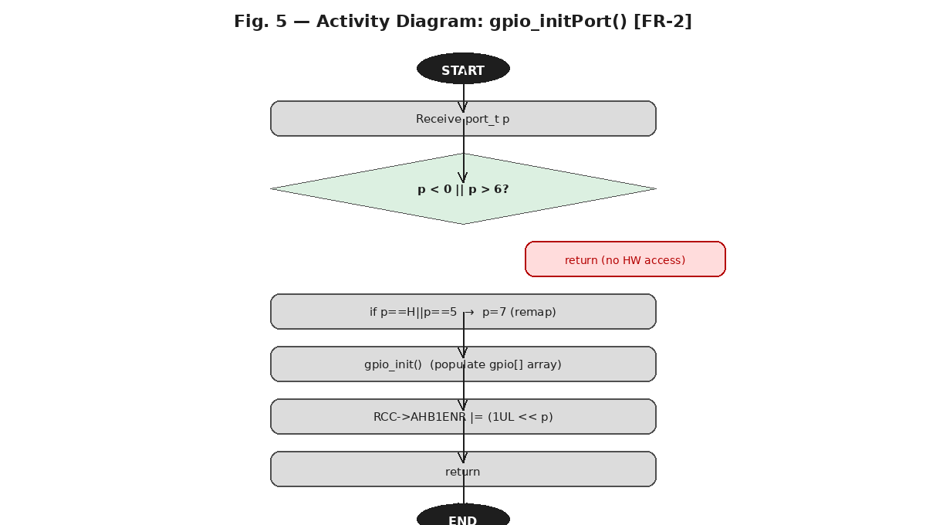
Fig. 7 — Activity Diagram: gpio_initPort() [FR-2]

gpio_setPinMode() — FR-3: Pin Mode Configuration
The sequence diagram uses an alt fragment: invalid arguments (port > 6, mode > 3, or pin > 15) cause an immediate return without any register access. On the valid path, a clear-then-set pattern writes the 2-bit MODER field.
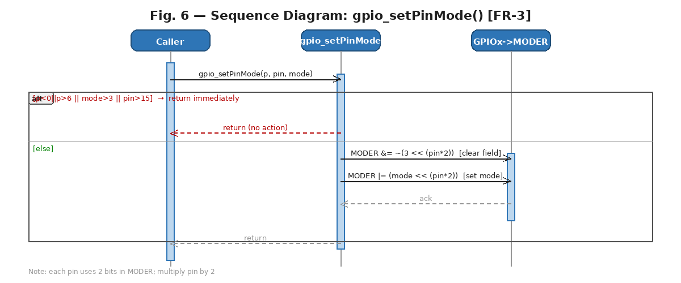
Fig. 8 — Sequence Diagram: gpio_setPinMode() [FR-3]

The activity diagram shows three validation diamonds in series before reaching the two-step hardware write. Both error and success paths meet at the end node.
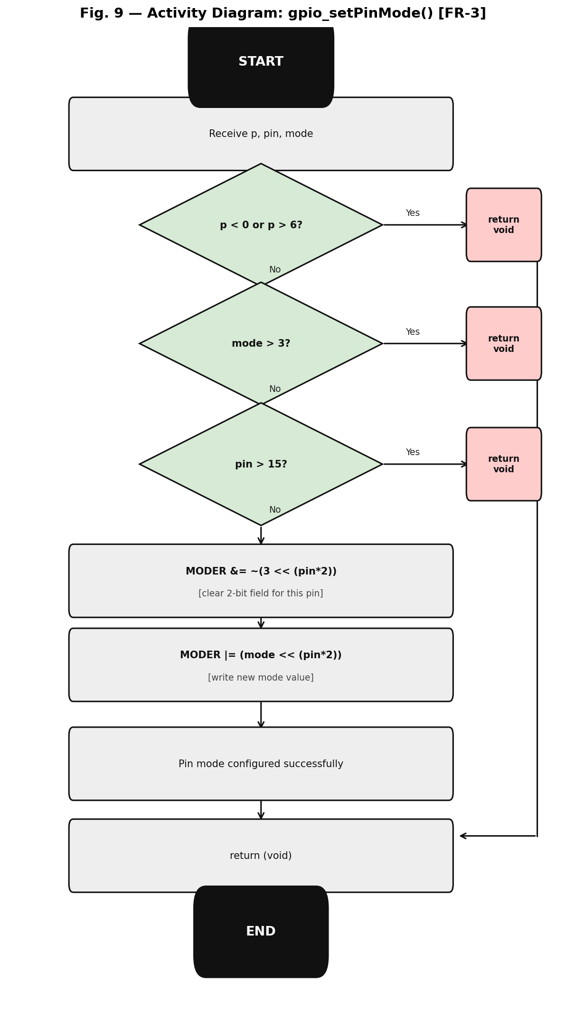
Fig. 9 — Activity Diagram: gpio_setPinMode() [FR-3]

gpio_setPin() — FR-4: Atomic Set HIGH
The sequence diagram illustrates the atomic set operation. After validation, a single write to BSRR bits[15:0] drives the pin HIGH without a read-modify-write cycle, making it interrupt-safe at the hardware level.
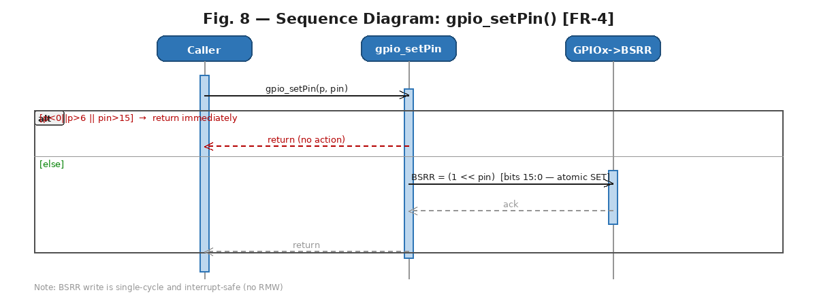
Fig. 10 — Sequence Diagram: gpio_setPin() [FR-4]

The activity diagram confirms the validate-then-act pattern: one decision diamond followed by the single hardware action BSRR = (1 << pin).
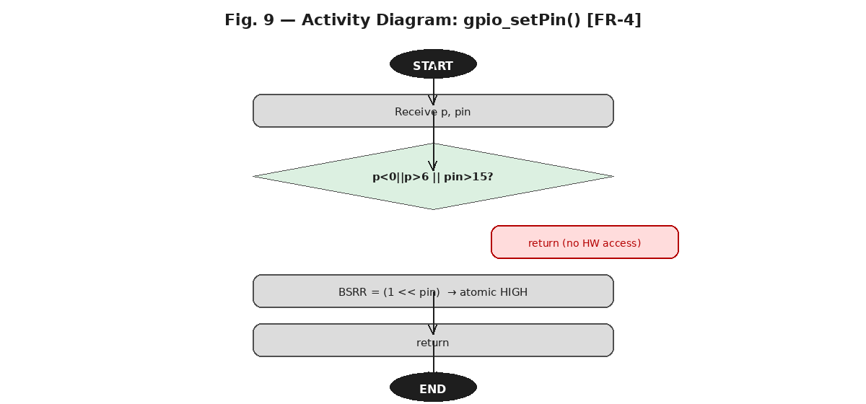
Fig. 11 — Activity Diagram: gpio_setPin() [FR-4]

gpio_clearPin() — FR-5: Atomic Clear LOW
The sequence diagram is symmetric to gpio_setPin() but writes to BSRR bits[31:16]. The expression (1 << (pin+16)) selects the reset channel, driving the pin LOW atomically.
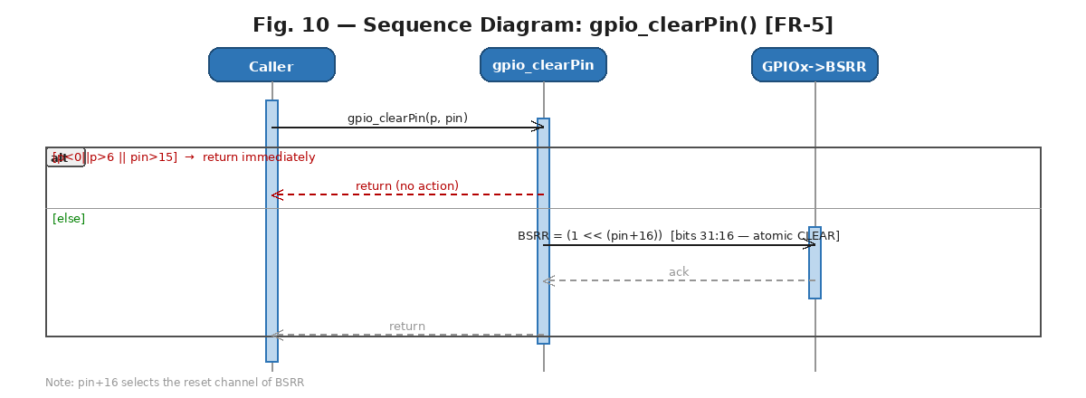
Fig. 12 — Sequence Diagram: gpio_clearPin() [FR-5]

The activity diagram mirrors gpio_setPin(): one validation decision then BSRR = (1 << (pin+16)).
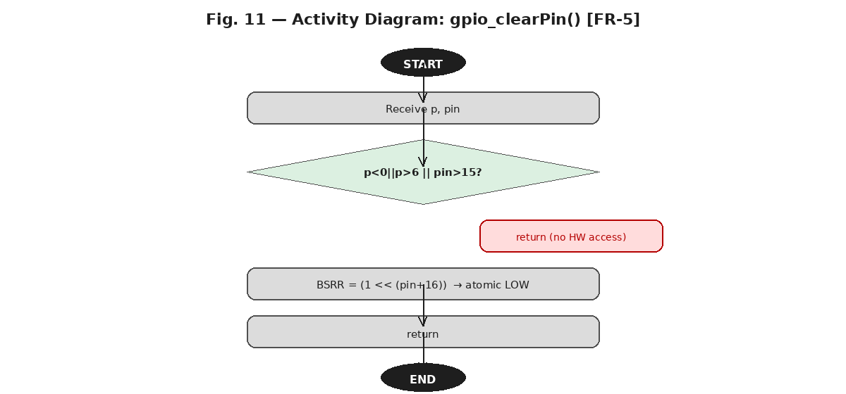
Fig. 13 — Activity Diagram: gpio_clearPin() [FR-5]

gpio_togglePin() — FR-6: XOR Invert
Unlike gpio_setPin() and gpio_clearPin(), toggle operates on the ODR register using XOR. The sequence diagram shows two outcome branches after the XOR: HIGH becomes LOW and LOW becomes HIGH.
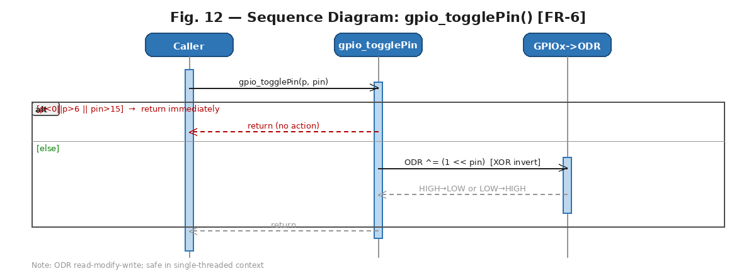
Fig. 14 — Sequence Diagram: gpio_togglePin() [FR-6]

The activity diagram shows an additional decision diamond after the ODR XOR action to represent both possible outcomes, both converging before the return node.
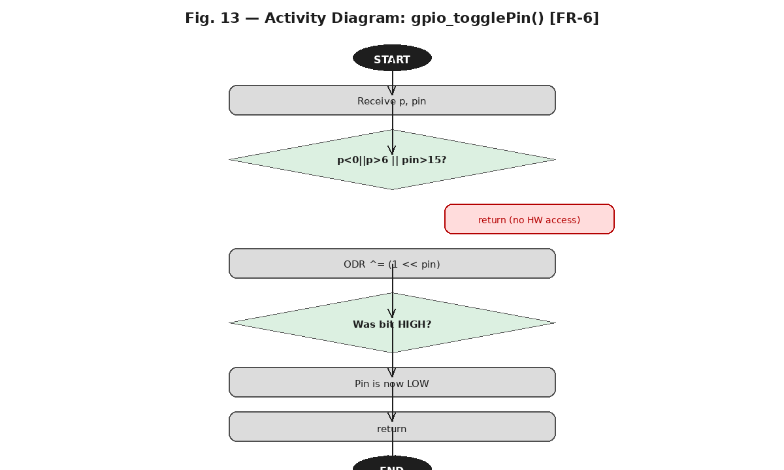
Fig. 15 — Activity Diagram: gpio_togglePin() [FR-6]

gpio_readPin() — FR-7: Input Read
The sequence diagram shows the most defensive validation in the driver: the port check uses strict inequalities (0 < p < 6 AND pin < 16). After validation, the IDR register is masked for the target pin and the result is returned as 0 or 1.
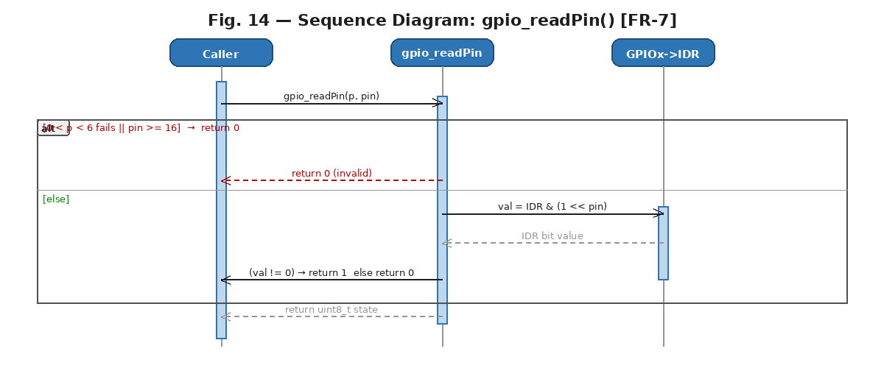
Fig. 16 — Sequence Diagram: gpio_readPin() [FR-7]

The activity diagram shows three decision diamonds: port/pin range check, IDR read, and value evaluation. All invalid paths return 0; the valid path returns 1 (HIGH) or 0 (LOW) based on the IDR bit.
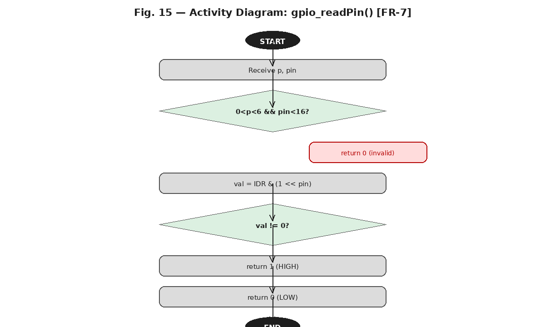
Fig. 17 — Activity Diagram: gpio_readPin() [FR-7]

gpio_setAlternateFunction() — FR-8: Alternate Function
The sequence diagram shows the two-stage hardware write: first MODER is set to AF mode (0b10), then the correct AFR bank is selected (AFR[0] for pins 0-7, AFR[1] for pins 8-15) and the 4-bit alternate function field is written using clear-then-set.
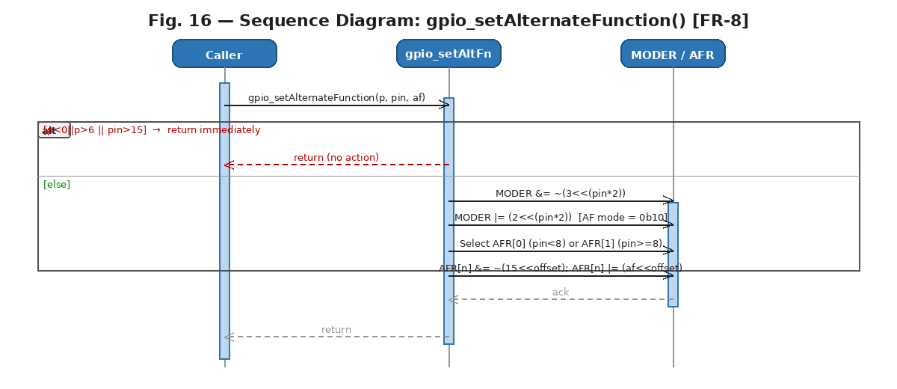
Fig. 18 — Sequence Diagram: gpio_setAlternateFunction() [FR-8]

The activity diagram contains the most decision nodes of any function: port/pin validation, MODER write, AFR bank selection, and the two-step register write. This guarantees that neighboring pins' AF assignments are never disturbed.
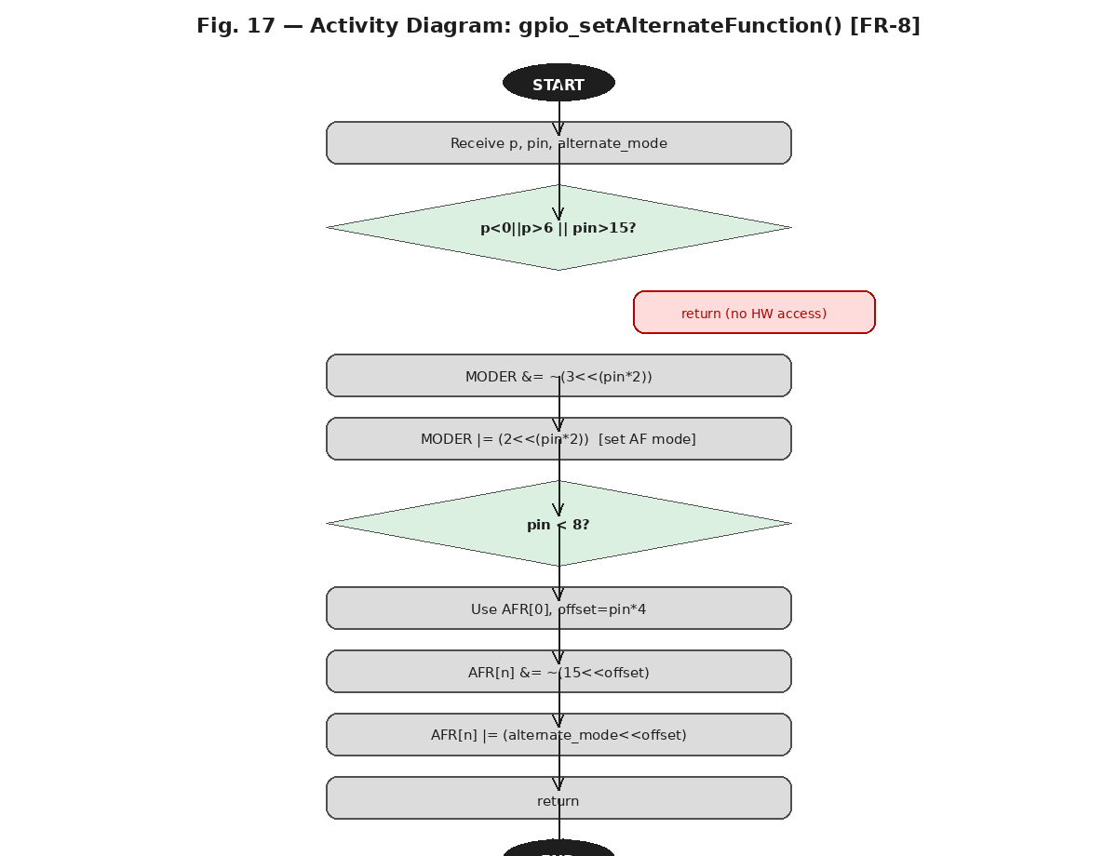
Fig. 19 — Activity Diagram: gpio_setAlternateFunction() [FR-8]

3.4. GPIO Driver Internals
The driver exposes one externally-visible global: the gpio[] array of GPIO_TypeDef* pointers, populated by gpio_init(). All hardware state resides in the STM32F411RE peripheral registers mapped at fixed AHB1 base addresses through stm32f4xx.h. No copies or shadows of these registers are maintained in software.
Initialization Flow: gpio_initPort() validates the port, remaps H→bit7 if needed, calls gpio_init() to populate the array, then writes (1UL << p) to RCC->AHB1ENR to enable the peripheral clock.
Pin Mode Configuration: gpio_setPinMode() applies a read-clear-set pattern to MODER. The pin number is multiplied by 2 because each pin occupies two bits: MODER &= ~(3 << (pin*2)); MODER |= (mode << (pin*2)).
Output Control: gpio_setPin() and gpio_clearPin() use BSRR for atomicity. gpio_togglePin() uses ODR XOR which is a read-modify-write, safe in single-threaded contexts.
Input Read: gpio_readPin() uses strict inequalities for range checking (0 < p < 6), reads IDR, and returns 1 or 0 based on the masked bit value.
Alternate Functions: gpio_setAlternateFunction() sets MODER to 0b10 first, then writes the 4-bit AF value to AFR[0] (pins 0-7) or AFR[1] (pins 8-15) using the offset (pin-8)*4 for the high bank.

4. Application Programming Interfaces

4.1. Data Types and Macros
- port_t: Enumeration identifying the target GPIO port.
- gpio[]: extern GPIO_TypeDef* gpio[GPIOs_SIZE] — hardware pointer array.

Enumerator | Value | Description
A | 0 | Port A → gpio[0] = GPIOA
B | 1 | Port B → gpio[1] = GPIOB
C | 2 | Port C → gpio[2] = GPIOC
D | 3 | Port D → gpio[3] = GPIOD
E | 4 | Port E → gpio[4] = GPIOE
H | 5 | Port H → gpio[5] = GPIOH (AHB1ENR bit 7)
GPIOs_SIZE | 6 | Sentinel / array size

4.2. Register Map
Register | Offset | Access | Used By / Purpose
RCC->AHB1ENR | 0x40023830 | R/W | gpio_initPort() — enable GPIO peripheral clock
GPIOx->MODER | +0x00 | R/W | gpio_setPinMode(), gpio_setAlternateFunction() — 2-bit mode per pin
GPIOx->IDR | +0x10 | Read-only | gpio_readPin() — read actual pin logic level
GPIOx->ODR | +0x14 | R/W | gpio_togglePin() — XOR invert of output state
GPIOx->BSRR | +0x18 | Write-only | gpio_setPin(), gpio_clearPin() — atomic bit set/reset
GPIOx->AFR[0] | +0x20 | R/W | gpio_setAlternateFunction() — AF for pins 0-7
GPIOx->AFR[1] | +0x24 | R/W | gpio_setAlternateFunction() — AF for pins 8-15

4.3. Function Definitions

gpio_init
Function Name | gpio_init
Syntax | void gpio_init(void)
Parameters (in) | N/A
Parameters (inout) | N/A
Parameters (out) | N/A
Return value | void — Always succeeds; returns no status.
Description | Initializes the GPIO subsystem (FR-1). Assigns gpio[0]=GPIOA, gpio[1]=GPIOB, gpio[2]=GPIOC, gpio[3]=GPIOD, gpio[4]=GPIOE, gpio[5]=GPIOH. Must be called before any other driver function.
Constraints | Only populates the gpio[] pointer array. Does not enable clocks or configure any hardware registers.
Available via | GPIO.h

gpio_initPort
Function Name | gpio_initPort
Syntax | void gpio_initPort(port_t p)
Parameters (in) | p | port_t — GPIO port to initialize. Valid values: A (0) through H (5).
Parameters (inout) | N/A
Parameters (out) | N/A
Return value | void
Description | Enables the clock for the specified GPIO port (FR-2). Validates p (exits if p < 0 || p > 6). Remaps H/5 to bit 7. Calls gpio_init() internally, then writes (1UL << p) to RCC->AHB1ENR.
Constraints | Port H (enum value 5) maps to AHB1ENR bit 7, not bit 5. This remap is handled internally. Function exits without side effects for invalid port values.
Available via | GPIO.h

gpio_setPinMode
Function Name | gpio_setPinMode
Syntax | void gpio_setPinMode(port_t p, uint8_t pin, uint8_t mode)
Parameters (in) | p | port_t — Target GPIO port. Valid range: 0–6.
 | pin | uint8_t — Target pin number. Valid range: 0–15.
 | mode | uint8_t — Mode to assign: 0=Input, 1=Output, 2=Alternate Function, 3=Analog.
Parameters (inout) | N/A
Parameters (out) | N/A
Return value | void
Description | Configures pin operating mode (FR-3). Validates port, mode, and pin. Applies read-clear-set to MODER: MODER &= ~(3 << (pin*2)); MODER |= (mode << (pin*2)). Multiplication by 2 accounts for 2 bits per pin.
Constraints | Returns immediately without hardware access if p<0||p>6, mode>3, or pin>15. Adjacent pins are unaffected.
Available via | GPIO.h

gpio_setPin
Function Name | gpio_setPin
Syntax | void gpio_setPin(port_t p, uint8_t pin)
Parameters (in) | p | port_t — Target GPIO port. Valid range: 0–6.
 | pin | uint8_t — Target pin number. Valid range: 0–15.
Parameters (inout) | N/A
Parameters (out) | N/A
Return value | void
Description | Atomically drives pin to logic HIGH (FR-4). Writes (1 << pin) to BSRR bits[15:0]. Single bus-cycle write; interrupt-safe without disabling interrupts.
Constraints | Pin must be configured as output via gpio_setPinMode(). Returns without action for invalid port or pin.
Available via | GPIO.h

gpio_clearPin
Function Name | gpio_clearPin
Syntax | void gpio_clearPin(port_t p, uint8_t pin)
Parameters (in) | p | port_t — Target GPIO port. Valid range: 0–6.
 | pin | uint8_t — Target pin number. Valid range: 0–15.
Parameters (inout) | N/A
Parameters (out) | N/A
Return value | void
Description | Atomically drives pin to logic LOW (FR-5). Writes (1 << (pin+16)) to BSRR bits[31:16]. The +16 offset selects the reset channel. Same atomicity as gpio_setPin().
Constraints | Returns without action for invalid port or pin. The 16-bit offset is mandatory; writing bits[15:0] would set the pin instead of clearing it.
Available via | GPIO.h

gpio_togglePin
Function Name | gpio_togglePin
Syntax | void gpio_togglePin(port_t p, uint8_t pin)
Parameters (in) | p | port_t — Target GPIO port. Valid range: 0–6.
 | pin | uint8_t — Target pin number. Valid range: 0–15.
Parameters (inout) | N/A
Parameters (out) | N/A
Return value | void
Description | Inverts current output state of pin (FR-6). Performs ODR ^= (1 << pin). HIGH becomes LOW and vice versa without the caller needing to know the current state.
Constraints | Non-atomic read-modify-write on ODR. Safe in single-threaded contexts where no ISR modifies the same pin concurrently. Returns without action for invalid args.
Available via | GPIO.h

gpio_readPin
Function Name | gpio_readPin
Syntax | uint8_t gpio_readPin(port_t p, uint8_t pin)
Parameters (in) | p | port_t — Target GPIO port. Valid range (strict): 0 < p < 6.
 | pin | uint8_t — Target pin number. Valid range: 0–15 (pin < 16).
Parameters (inout) | N/A
Parameters (out) | N/A
Return value | uint8_t — Returns 1 if pin is HIGH, 0 if LOW or arguments are invalid.
Description | Reads current logic level from IDR (FR-7). Validates 0 < p < 6 AND pin < 16. If (IDR & (1 << pin)) != 0 returns 1; else returns 0. Also returns 0 for any invalid argument.
Constraints | Note: the strict port range check (0 < p < 6) excludes port A (value 0). This is an implementation quirk — port A reads will always return 0. All other functions use inclusive checks.
Available via | GPIO.h

gpio_setAlternateFunction
Function Name | gpio_setAlternateFunction
Syntax | void gpio_setAlternateFunction(port_t p, uint8_t pin, uint8_t alternate_mode)
Parameters (in) | p | port_t — Target GPIO port. Valid range: 0–6.
 | pin | uint8_t — Target pin number. Valid range: 0–15.
 | alternate_mode | uint8_t — Alternate function number (0–15). Refer to STM32F411RE datasheet Table 9.
Parameters (inout) | N/A
Parameters (out) | N/A
Return value | void
Description | Configures alternate function for a pin (FR-8). Sets MODER to AF mode (0b10). Selects AFR[0] for pins 0-7 or AFR[1] for pins 8-15. Clears and writes the 4-bit field: AFR[n] &= ~(15 << offset); AFR[n] |= (alternate_mode << offset).
Constraints | Only sets MODER and AFR. Caller must ensure alternate_mode matches the desired peripheral (UART, SPI, I2C, TIM, etc.) per the STM32F411RE datasheet. Returns without action for invalid port or pin.
Available via | GPIO.h

5. Future Enhancements
- Error return codes: Add a GPIO_Status_t return type to all functions so callers can detect invalid arguments at runtime rather than silently.
- gpio_readPin() port validation fix: The strict inequality (0 < p < 6) incorrectly excludes port A (value 0). This should be corrected to use inclusive checks (0 <= p < GPIOs_SIZE) consistent with all other functions.
- Pull-up/pull-down configuration: Add gpio_setPull() or extend gpio_setPinMode() to configure the PUPDR register per pin.
- Output type configuration: Add support for open-drain vs. push-pull output via OTYPER register.
- Interrupt support: Add gpio_configInterrupt() and gpio_enableInterrupt() to configure EXTI lines for edge-triggered detection without polling.
- Port-wide configuration: Add gpio_initPortFull() to configure all 16 pins in a single call using a configuration array.
- Portability layer: Abstract RCC and GPIO register definitions for reuse on other Cortex-M devices (STM32F0, STM32L4) without modifying driver logic.
- Unit test suite: Develop hardware-independent tests using mock register definitions to validate all driver functions and error paths on a host machine.

